CREATE & CONFIGURE IBM CLOUD SERVICES

**CREATE A DATABASE IN CLOUDANT DB**

|  |  |
| --- | --- |
| **Date** | 18 November 2022 |
| **Team ID** | PNT2022TMID24184 |
| **Project Name** | Personal Assistance For Seniors Who Are Self Reliant |

CLOUDANT SERVICE:

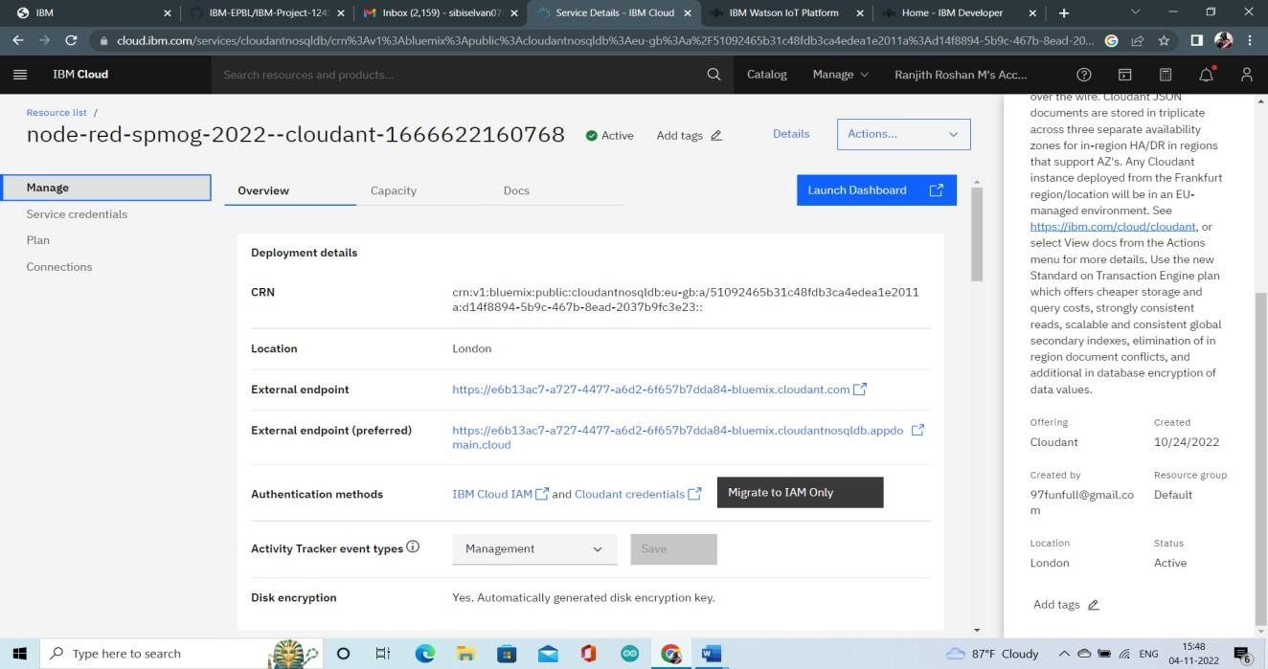

SERVICE CREDENTIALS:

